**CREATING STUDENT TABLE AND WRITING QUERIES**

1. Create a student table with all student details.

CREATE SCHEMA Student;

CREATE TABLE `student`.`student` (

`Student_ID` INT NOT NULL,

`Student_name` varchar(45) NOT NULL,

`Batch_num` VARCHAR(45) NOT NULL,

PRIMARY KEY (`STUDENT_ID`, `Student_name`));

INSERT INTO `Student`.`student` (`Student_ID`, `Student_name`, `Batch_num`) VALUES ('1', 'rocky', 'B14'),('2', 'manny', 'B14'),('3', 'fenny', 'B12'),('4', 'jack', 'B12'),('5', 'JM', 'B18'),('6', 'sandy', 'B18'),('7', 'sims', 'B01'),('1', 'tim', 'B02');

OUTPUT:

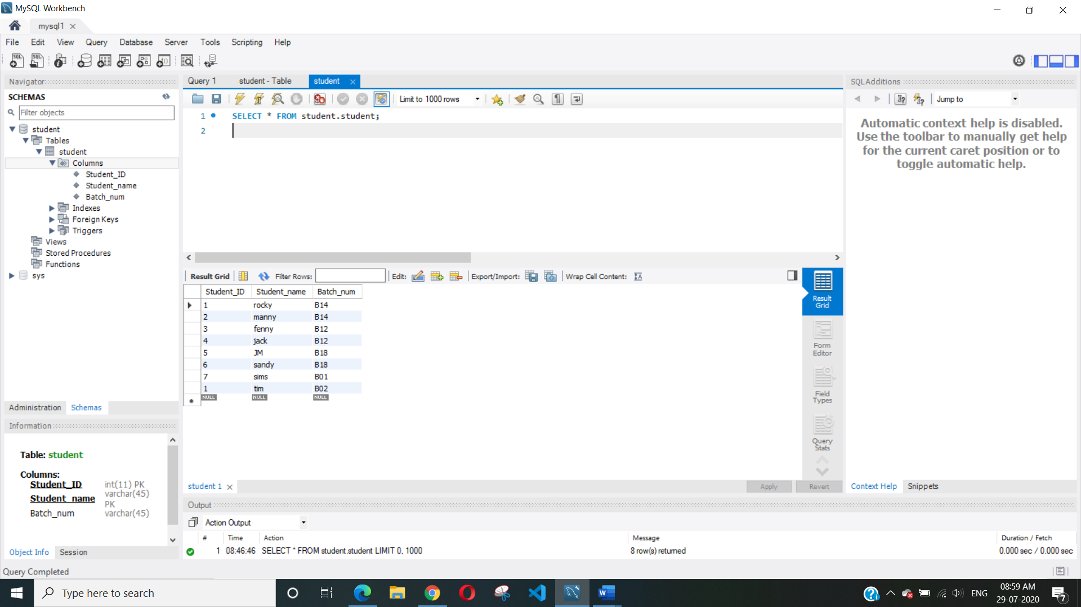

1. Create a batch table with multiple batches and its corresponding details.

CREATE TABLE `Student`.`batch` (

`Id` INT NOT NULL,

`Student_name` varchar(45) NOT NULL,

`Batch_ID` VARCHAR(45) NOT NULL,

`JAN 2020` VARCHAR(45) NULL,

`MARCH 2020` VARCHAR(45) NULL,

`JUNE 2020` VARCHAR(45) NULL,

PRIMARY KEY (`Id`));

OUTPUT:

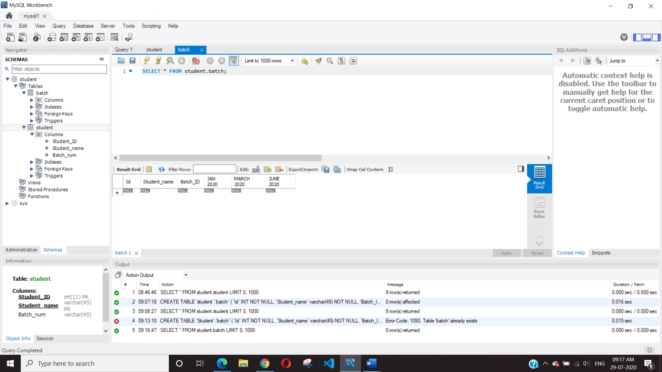

1. Write a query to insert student details in student table

INSERT INTO `Student`.`student` (`Student_ID`, `Student_name`, `Batch_num`) VALUES ('2', 'Ginny', 'B02'),('1', 'Gary', 'B01');

OUTPUT:

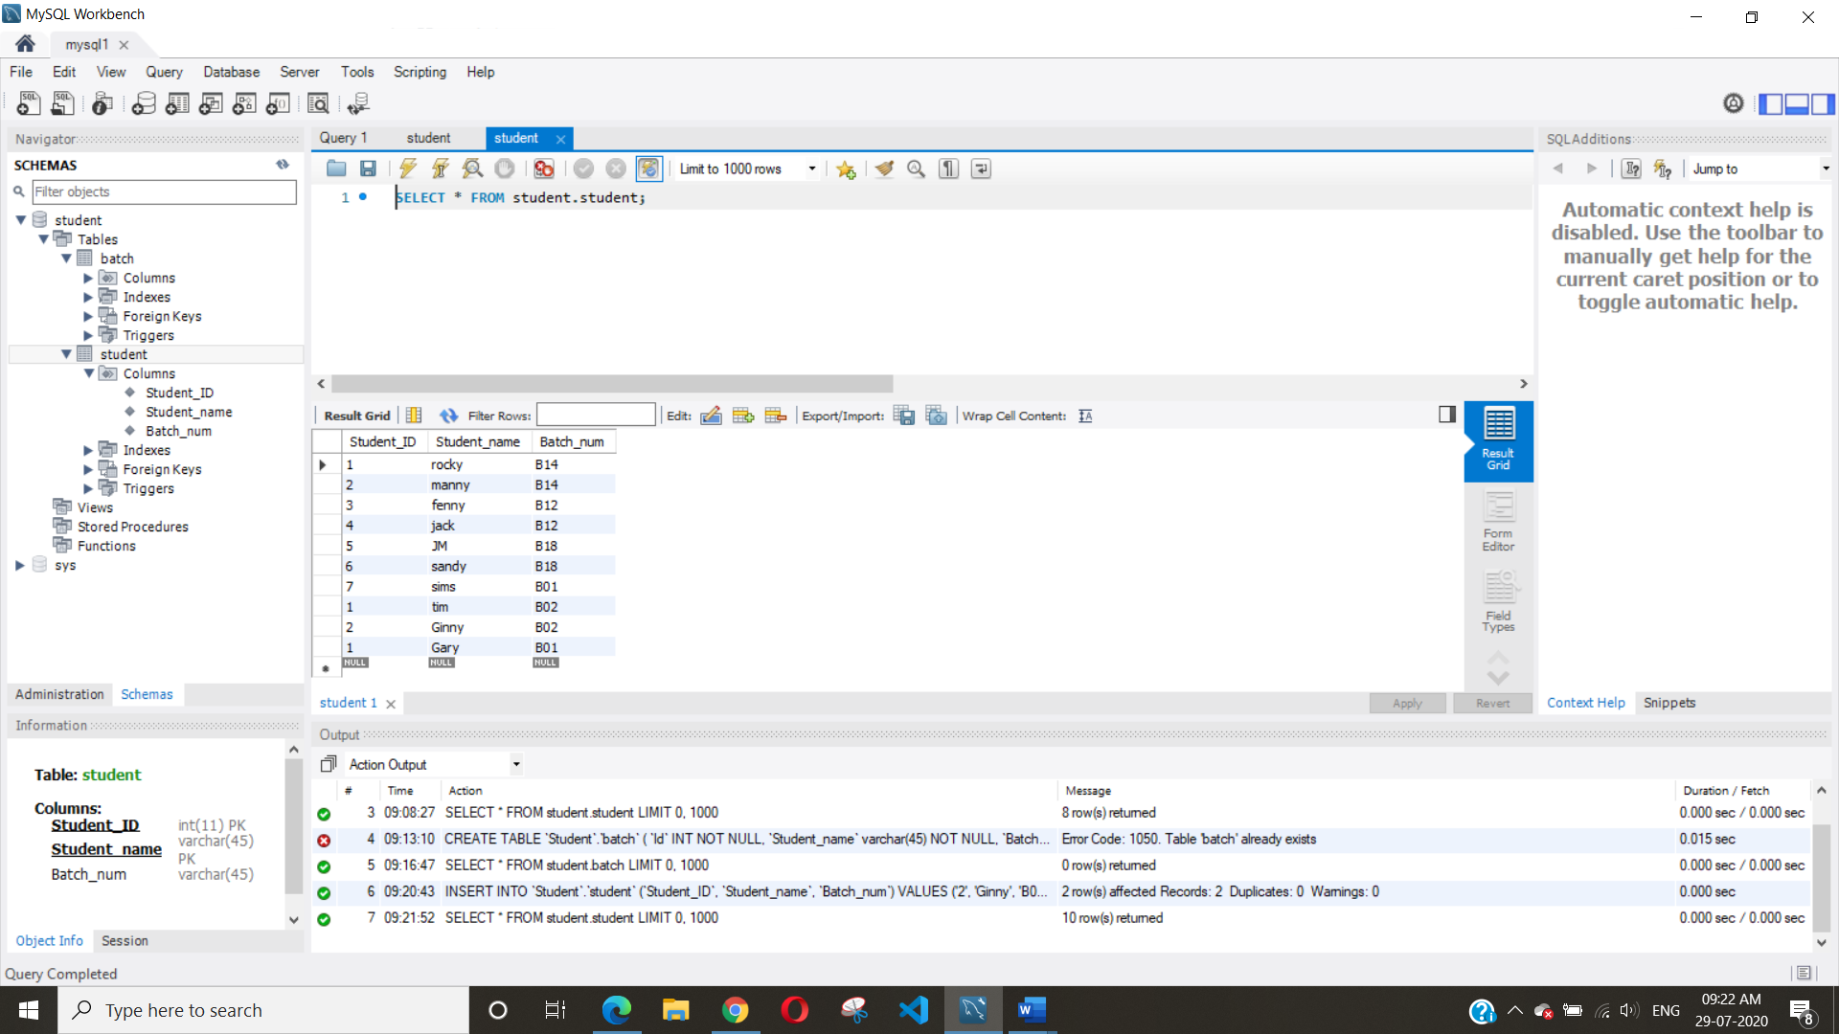

1. Write a query to insert batch details in batch table

INSERT INTO `student`.`batch` (`Id`, `Student_name`, `Batch_ID`, `JAN 2020`, `MARCH 2020`, `JUNE 2020`) VALUES ('1401', 'rocky', 'B14','-','Yes','-'),('1402', 'manny', 'B14','-','Yes','-'),('1203', 'fenny', 'B12','-','Yes','-'),('1204', 'jack', 'B12','-','Yes','-'),('1805', 'JM', 'B18','-','-','Yes'),('1806', 'sandy', 'B18','-','-','Yes'),('0107', 'sims', 'B01','Yes','-','-'),('0201', 'tim', 'B02','Yes','-','-'),('0202', 'Ginny', 'B02','Yes','-','-'),('0101', 'Gary', 'B01','Yes','-','-');

OUTPUT:

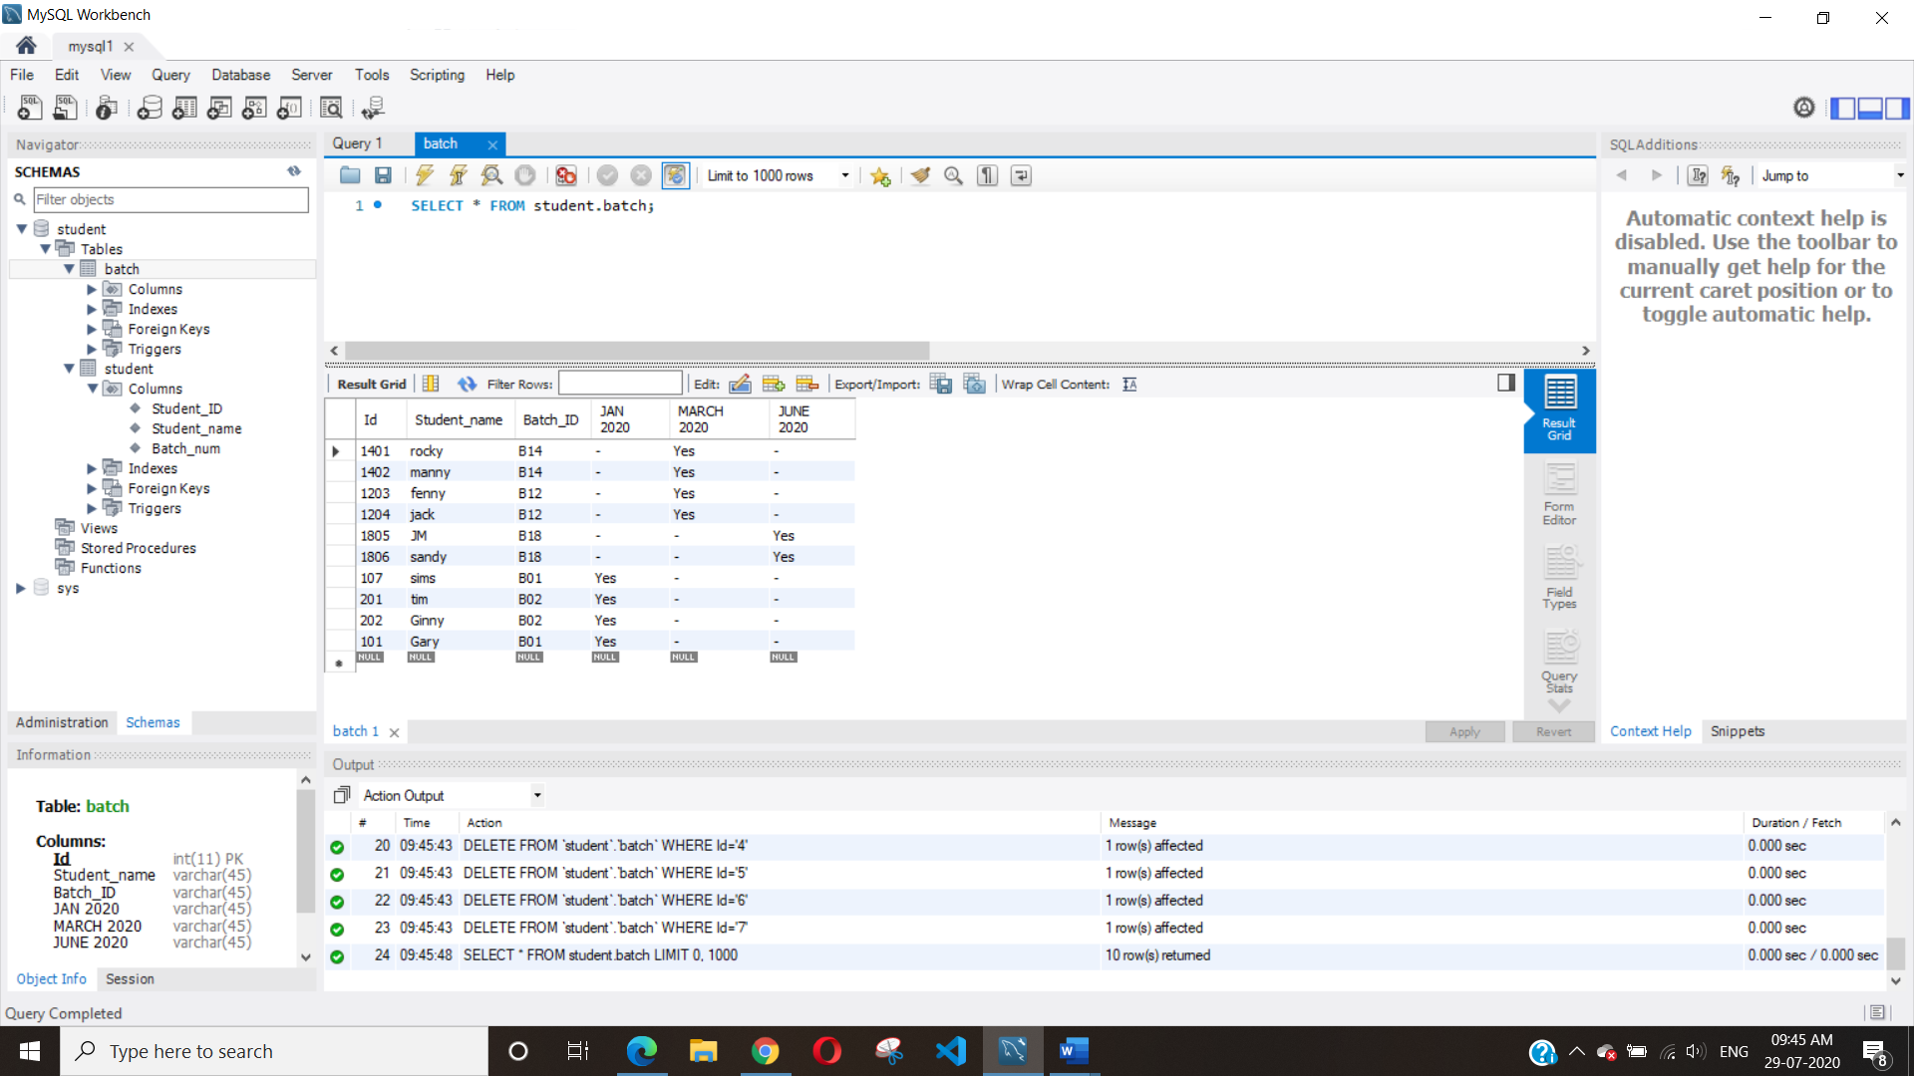

1. Write a query to Mark attendance for the students at respective batch on Jan 23 2020.

UPDATE `Student`.`batch`

SET `Jan 23 attendence` = "Present"

WHERE Id = 0107;

OUTPUT:

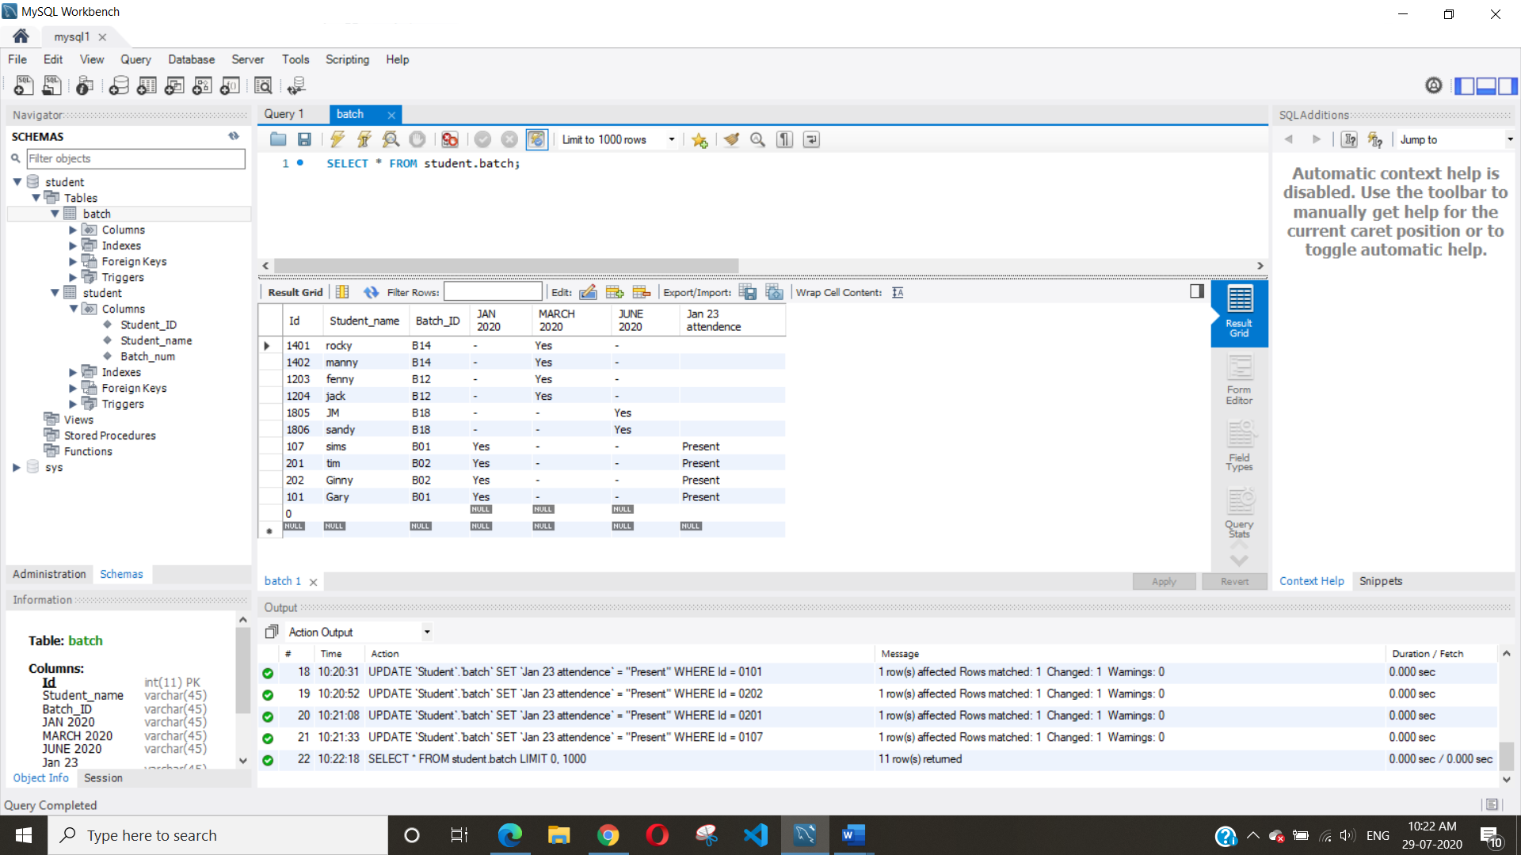

1. Write a query to display the batch details and attendance history of student 1.

SELECT `Student_name` , `JAN 2020`,`Jan 23 attendence`

FROM Student.batch

WHERE `Id` = 0201;

OUTPUT:

